**These are 5 unreported bugs:﻿﻿**

**Bug 1:**

**While betting age must be 18 or higher, Game does not ask for age verification and it also does not ask for name for every new player (gambler). It remains same every time "Fred".**

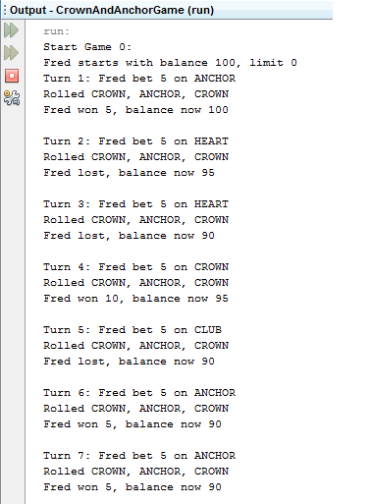

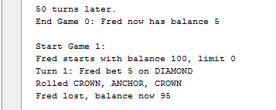

**Bug 2:**

**Rolls of each round are getting same at every time from starting to until the game ends.**

**e.g.: It rolls repetitive dice every time from starting to end, that is**

**If game starts with ANCHOR, ANCHOR, and CLUB every time remain same (image: 1)**

**If game starts from CROWN, ANCHOR, and CROWN every time remain same (image: 2)**

**Examples:**

 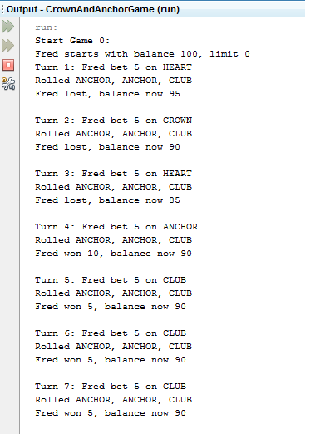

**Bug 3:**

Game does not rolled “**SPADE**” et al.

It every times rolled from only this FIVE dice: **CLUB, CROWN, ANCHOR, HEART and DIAMOND**.

 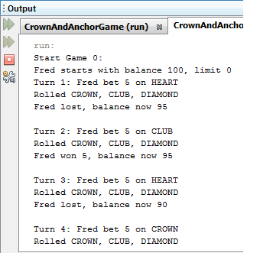

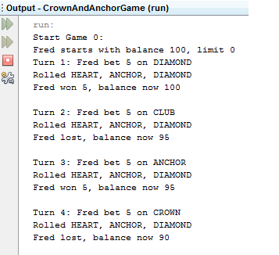

**Bug 4:**

**Betting amount of the each bet is always 5, even the gambler has the balance greater than 5.**



**Bug 5:**

**Game does not ask/prompt for new turn after Win/Loss weather gambler wants to play game again?**

**Rather it uses “Enter key” to play for next round.**

